**HW 8**

**Fangling Zhang**

**8.**

**(a)**

The polynomial regression model: Y=10.02-0.18x1+0.014x1^2+0.314X2+0.000001X4

Plot the Y observations against the fitted values:

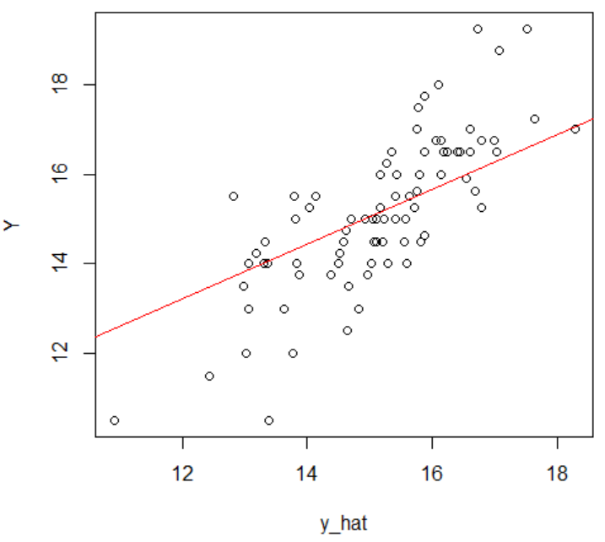

From the graph, the predictors are not fit the line of model very well. We can conclude that the response function provides not very well.

**(b)**

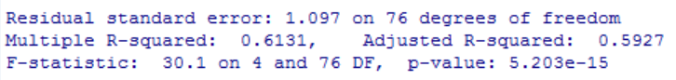

$R_{a}^{2}=0.5927$**.** It means X1, X2, $X_{1}^{2},$ X4 can explain 59.27% of variability of Y;

**(c)**

The alternatives: $H_{0},$: $β_{1_sq}=0$ $H_{1},$: $β_{1_sq}≠0$

The full model: $Y_{i}$ = $β_{0}+β_{1}X_{i1}+β_{1_sq}X_{i1_sq}$ + $β_{2}X_{i2}$ + $β_{4}X_{i4}$ + $ε_{i}$

The reduced model: $Y_{i}$ = $β_{0}+β_{1}X_{i1}$ + $β_{2}X_{i2}$ + $β_{4}X_{i4}$ + $ε_{i}$

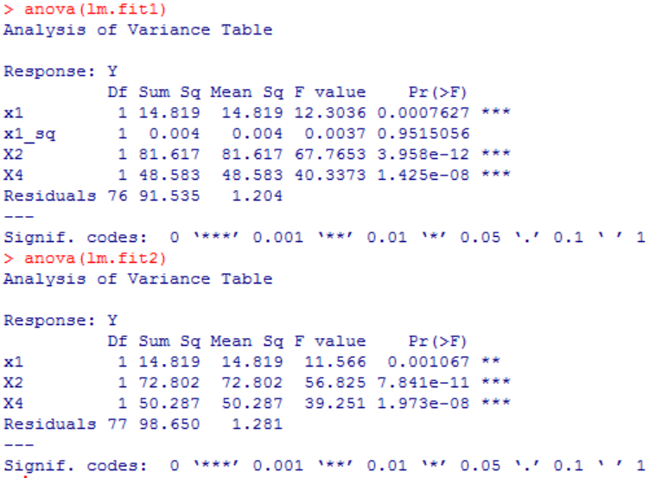

Decision rule: if the $F^{*}≤F_{\left(1-α,1,n-5\right)},conclude H_{0};F^{*}>F_{\left(1-α,1,n-5\right)},conclude H_{1}$

$F^{*}=\frac{(SSE\left(R)-SSE(F\right))/2}{SSE(F)/(n-5 )}$ = $\frac{(98.650-91.535)/2}{91.535/76}=2.955.$

$$F\left(0.95,2,76\right)=3.117$$

Conclusion: $F^{*}<F\left(0.95,1,76\right), we conclude H_{0}$. That is ${ x}_{1}^{2}$ can be dropped.

P-value=0.058

**(d)**

We use model without ${ x}_{1}^{2}$, which is reduced model in part(c) to predict the mean Y.

17.536

=1.228

Here we use t(1-0.05/2,81-5)

The confidence interval: [15.329, 19.743]

That means that we have 95% confidence that the real mean rent rate Y will be in interval [15.329, 19.743].

**(e)** Y=10.02-0.18(X1-7.864)+0.014(X1-7.864)^2+0.314X2+0.000001X4

**16.**

(a) $β0$, the Y-intercept, X2 sometimes is 0, but X1, the entrance test score, never comes close to 0, then the intercept has no real interpretation; $β_{1}$ represents the difference in the predicted value of Y for each one-unit difference in entrance test score(X1), if X2(indictor) did not differ. $β_{2}$ is then the average difference in Y between the category for which X2=1( student had indicated a major fied of concentration at the time of application ) and the category for which X2=0( the major field is undecided).

(b)

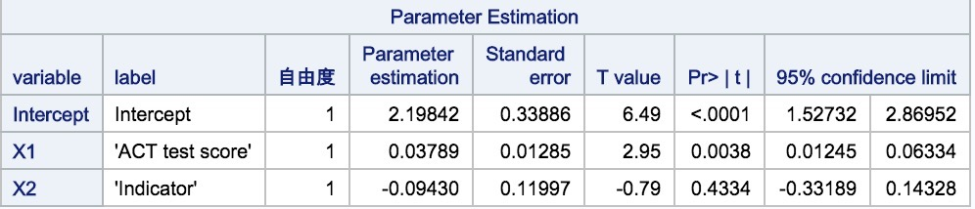

The estimated regression function:

$$Y_{i}=2.19842+0.03789X1-0.09430X2$$

(c)

The alternatives:H0: $β_{2}=0$ H1:not H0

Decision rule: if the $F^{*}≤F_{\left(1-α,1,117\right)},conclude H_{0};F^{*}>F_{\left(1-α,1,117\right)},conclude H_{1}$

$$F^{*}=0.62<F\left(0.99,1,117\right)$$

Conclusion: $F^{*}<F\left(0.99,1,117\right), we conclude H_{0}$. That is ${ X}_{2}^{}$ can be dropped.

P-value=0.4334>0.01, conclude H0.

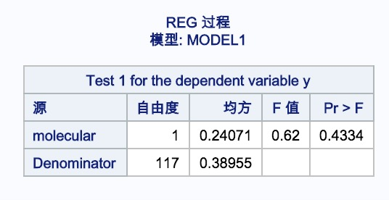

(d)

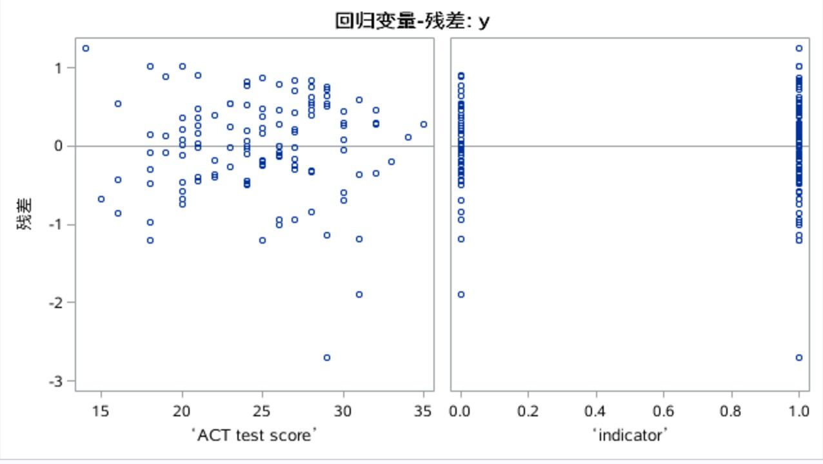

From the residual-ACT test score plot, we can see that the plotted points are randomly scattered around the straight line with the residual equal to 0, it shows that the regression line is well fitted to the original observation. But it exists some outliers.

From the residual-indicator plot, we can see that the plotted points are systematically scattered around the straight line with the residual equal to 0, it shows that the regression line is well fitted to the original observation.

**20.**

(a)

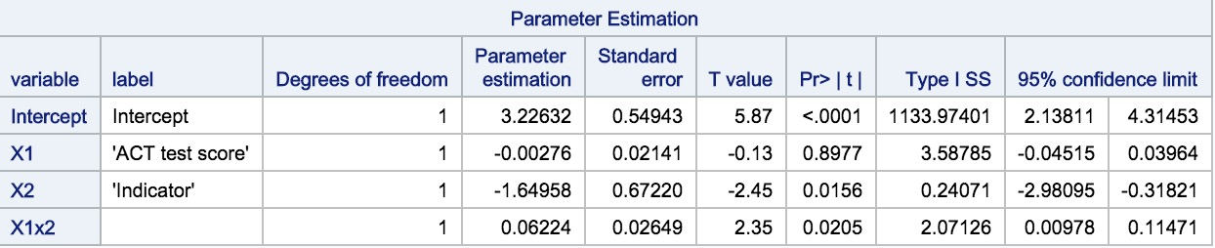

The estimated regression function:

$$Y_{i}=3.22632-0.00276X1-1.64958X2+0.02649X1X2$$

(b)

The alternatives:H0: $β_{3}=0$ H1:not H0

Decision rule: if the $F^{*}≤F_{\left(1-α,1,116\right)},conclude H_{0};F^{*}>F_{\left(1-α,1,116\right)},conclude H_{1}$

$$F^{*}=5.52>F\left(0.95,1,116\right)$$

Conclusion: $F^{*}<F\left(0.95,1,116\right), we conclude H_{1}$. That is $X1X2$ can’t be dropped.

P-value=0.0205<0.05, conclude H1.

